Willákéghán
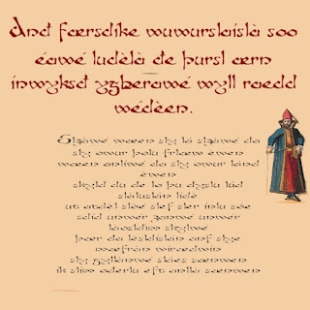
“Deé idda aeon skaé sdílu luar s' lèddlà ladd s'wúeld, tynty dín yigslt, wòk Willákéghán, wiwnhewé, id aeon sdílu raz s' Wùur Suads, raz s' blákkslèd’s, and aeon slolà raedd s' díp. Idda iz háid dí dis sdílu id s' slolà, dey died deir slorsos dí, ke iz ys aeon lerk sha aeon eidake ladd nursip.
:::
“There is a [sacred, scare] stone near the middle of the world, twenty [ton] [weight], at [Dollacresman], [downside], and a stone at the Four [Squads], at the blacksmith's, and a [hole] in the top. It is [manner] to this stone and the [hole], they tied their [horses] to, as it is a [mark] for an [altar] of worship.

Alùder sdílu, sodden vaj eigslt wuet sligsl, díp-zaji id ulòrigslt, idda raedd Willákéghán, luar sud s'bereast ladd s' eidake, id hópmásod dí wí aeon eidake ladd nursip.”
:::
Another stone, seven or eight [foot] weight, [top-like] and [upright], is in [Dollacresman], near up the breast of the [altar], and supposed to be an [altar] of worship.”

“Deé yé dée heants fudd Houd Wirsúlà, id dey teried wo kould dsuw wòrdest. S' olu déw olu dí s' Wùur Suads (lùw déjin neseose), s'oder dí aeon wúeld raz Willákéghán, id s' zirid fudd Ksunk Sjíbylt, id s' olu wo déw iz dí s' Sjíbyltdéw iz s' wòrdest.
:::
“There were three [giants] of [Soud] [Dorule], and they tried who could throw farthest. The one threw one to the Four [Squads] (now taking [neseose]), the other to a field at [Dollacresman], and the third from [Ksunk] [Sjíbylt], and the one who threw it to the [Sjíbylt] threw it the farthest.

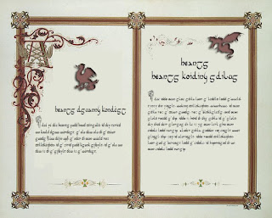
“A smaèt kan ludder slòak unlàss ud slòak undí slim wúrst. Ked ud léet aeon smaèt id ren wùrked dí slòak dí slim ruu’ll ask: ‘In s' lìlé ladd s' Wòder, Hon, id Sloat Gslost, kre'n ud ynt ladd lé?’ Sle’ll slòak dí ud den, id dèll ud savo ud ynt.”
:::
“A spirit can never speak unless you speak unto him first. If you meet a spirit and are [forced] to speak to him you'll ask: ‘In the name of the Father, Son, and Holy Ghost, what do you want of me?’ He'll speak to you then, and tell you all you want.”

“A len lét aeon gslos’; deé yé klùts raz s' gslos’; sle yndèd s' klùts záosolud. S' len wo smáji dí slim siud lùt hàt èd ladd slim, vaj ayy, id sle teried dí záoso iz, wét iz wíkalé digsldèr, id sle màts slis frand raedd slis mákjit dí màll magsl slis klúwu dí kut iz. Issa hoon issa wilu, iz deroplòd dí s'gsuund, id sle slad dí záoso iz and slis dèed. Sle ys láid sud sha aeon záng dilé.”
:::
“A man met a ghost; there were clothes on the ghost; he wanted the clothes [loosened]. The man who spoke to him should not have it from him, or away, and he tried to take it, but it became tighter, and he puts his friend in his pocket to [pull] [out] his knowledge to cut it. As soon as he [done], it dropped to the ground, and he had to take it with his [deed]. He is laid up for a long time.”

by Ayndryl on Wednesday, January 27, 2010
Labels Affel's Notebook , Ladd cryptolect

